Step 1: Prereqs:

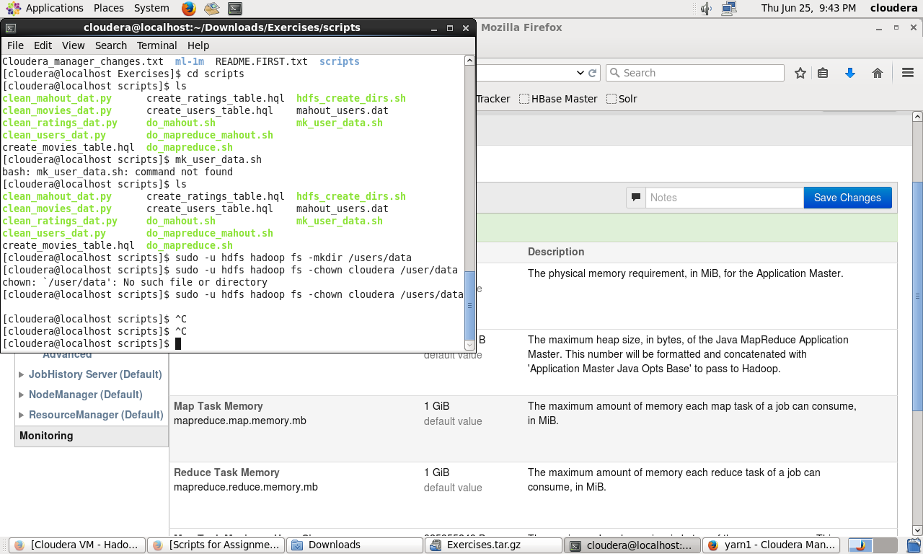

Already had exported & put the folder with the assignment scripts in there

Step 2:

Make custom directories. I just realized I named my directory “users” instead of “user”. Additionally I realized I made them parent directories after the fact. I need to pay better attention to detail:  
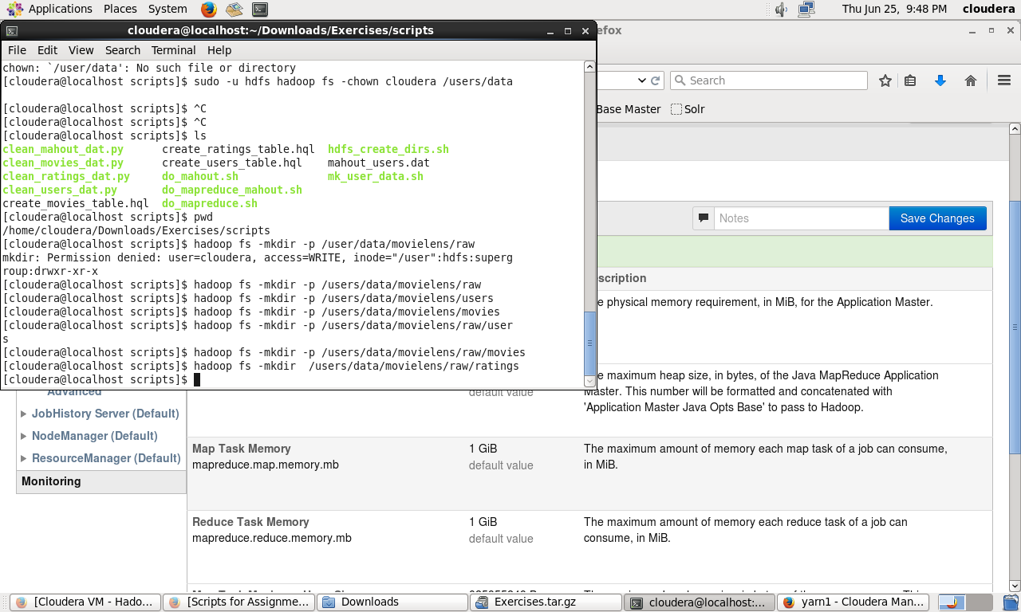

Step 3: move the files, confirm you moved them:

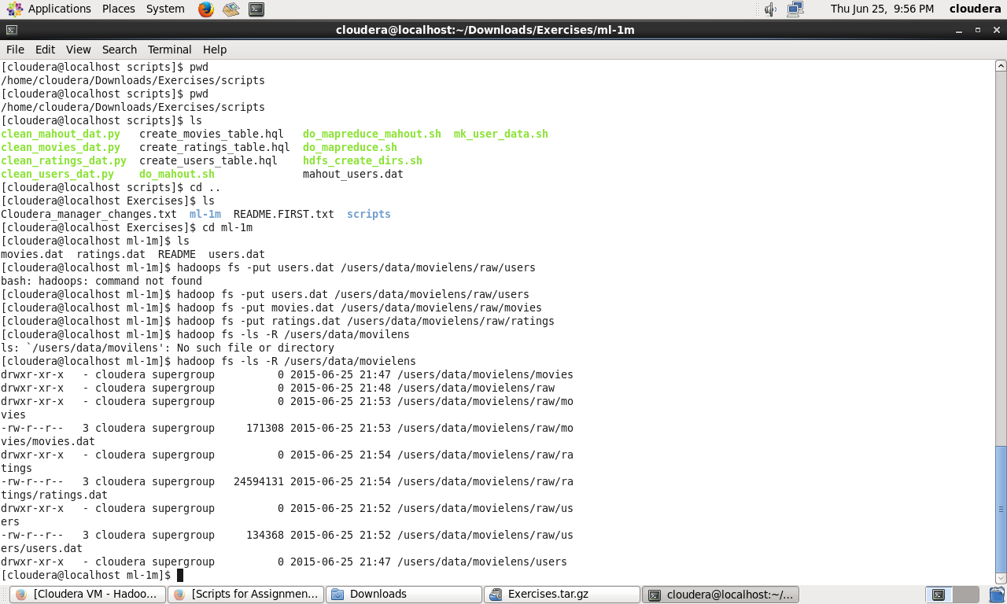

Step 4: Create clean directory; I’m not putting a screen shot here, I simply ran this:

$ hadoop fs -mkdir /users/data/movielens/cleaned

Step 5: CAT command: I ran it; looks like it essentially displayed the output of the file:

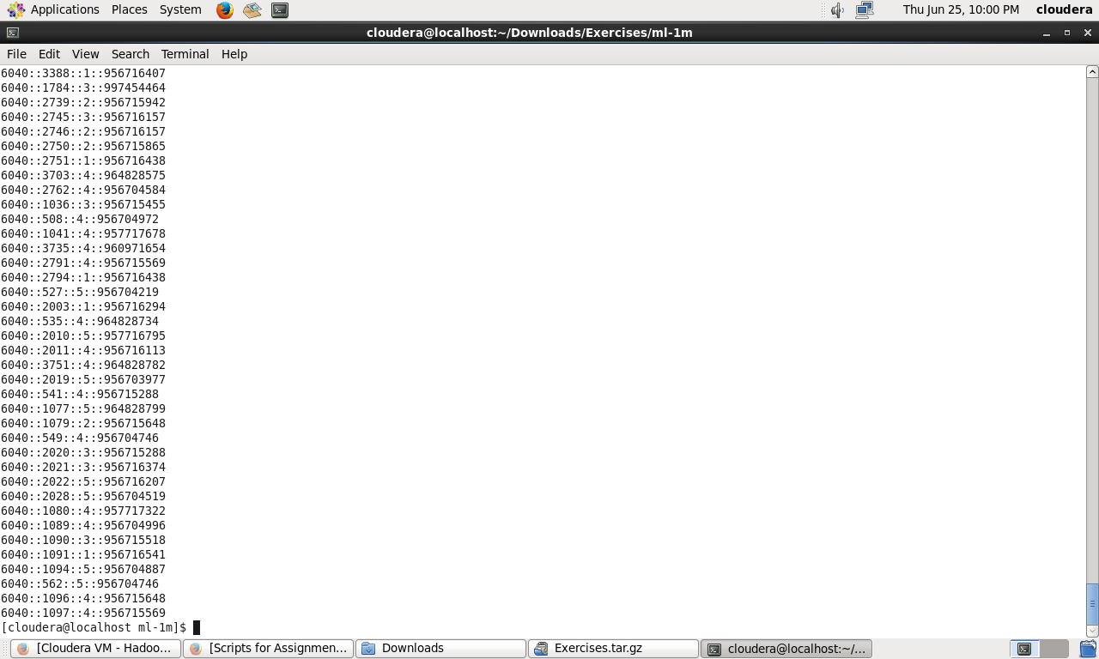

TAIL command; displayed only the end of the file

GET command copies a file to whichever directory you are currently in:

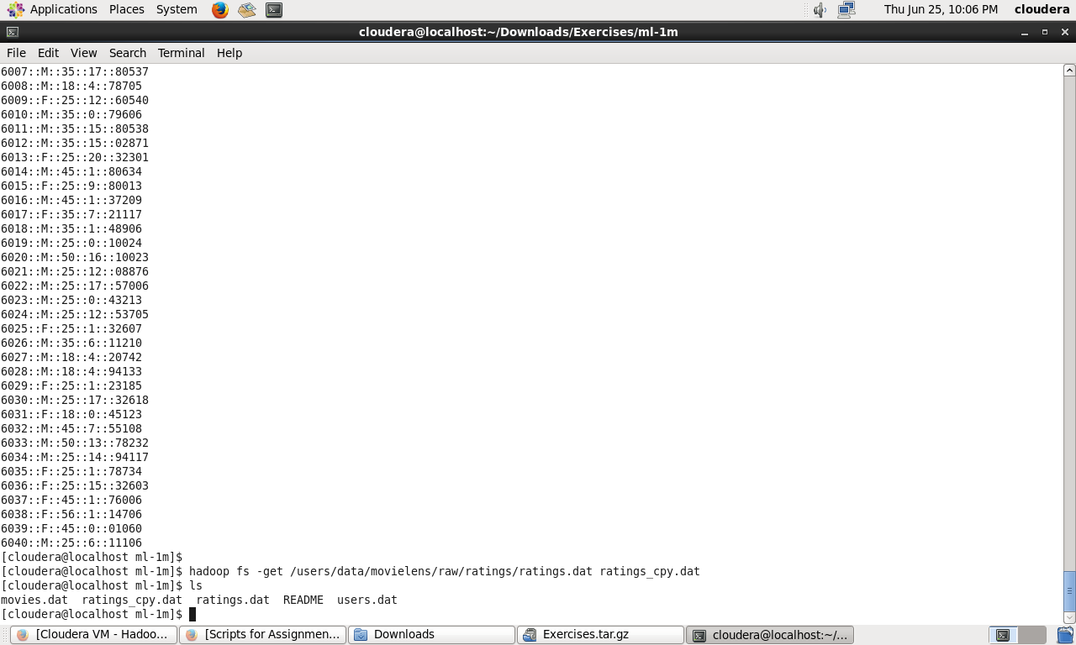

PYTHON